Copyright for test papers and marking guides remains with West Australian Test Papers.
Test papers may only be reproduced within the purchasing school according to the advertised Conditions of Sale.
Test papers should be withdrawn after use and stored securely in the school until 11th June 2021.



Marking Guide

Biology Unit 3

2021

Section One: Multiple-choice 30% (30 Marks)

Question | Answer
1 | c
2 | a
3 | b
4 | d
5 | c
6 | d
7 | c
8 | b
9 | a
10 | c
11 | a
12 | d
13 | c
14 | b
15 | d
16 | b
17 | d
18 | b
19 | d
20 | c
21 | c
22 | d
23 | b
24 | a
25 | c
26 | b
27 | b
28 | a
29 | b
30 | c

Section Two: Short answer 50% (100 Marks)

Question 31 (20 marks)

(a) Define the following terms.

(i) Genotype (1 mark)

Description | Marks
Specific combination of alleles at particular gene loci (for a trait) in an organism/cell. | 1
TOTAL | 1

(ii) Phenotype (1 mark)

Description | Marks
Visible/expressed characteristic (based on the genotype). | 1
TOTAL | 1

(ii) Genome (1 mark)

Description | Marks
All the genetic material contained in a cell (coding and non-coding). | 1
TOTAL | 1

(b) Explain the difference between a gene and an allele. (2 marks)

Description | Marks
A gene is a sequence of nucleotides coding for a trait/protein. | 1
Alleles are variant forms of a gene (inherited from each parent). | 1
TOTAL | 2

(c) Identify the factors that determine an organism's phenotype. (2 marks)

Description | Marks
Genotype | 1
Environment/selective pressures | 1
TOTAL | 2

In snow peas, the pod shape can be either flat or curled, with flat pods showing dominance over curled pods. A market gardener wanted to ensure all future snow pea crops only produced flat pods.

(d) Explain how the market gardener could determine whether a snow pea plant is homozygous or heterozygous for flat pods. Use the Punnett squares below to help support your answer. (8 marks)

 | F | F
F | FF | FF
F | FF | FF
 | F | f
F | FF | Ff
f | Ff | ff
Homozygous cross Heterozygous cross

Description | Marks
Punnet squares
Two correctly completed Punnett squares - one showing homozygous dominant cross and one showing heterozygous cross. | 1 - 4
Explanation
Self-pollinate flat pea pod phenotypes. | 1
Homozygous dominant plant will only produce offspring showing 100% flat pea pod phenotype (and therefore genotype). | 1
Heterozygous plant cross will produce ratio of genotypes 1:2:1 for FF, Ff and ff. | 1
Heterozygous phenotypes of offspring will be 75% flat pea pod and 25% curly pea pod. | 1
TOTAL | 8

While harvesting the snow peas, the market gardener noticed several plants had produced pods that were twice as big as the 'normal' pea pods. His neighbour suggested it was the result of a mutation that is not uncommon in plants.

(e) Identify and describe the type of mutation that could cause this phenomenon. (3 marks)

Description | Marks
Polyploidy | 1
Chromosomal mutation during meiosis. | 1
Cells contain more than two haploid (n) sets of chromosomes. | 1
TOTAL | 3

(f) Explain one (1) issue associated with growing crops with a high level of homozygosity. (2 marks)

Description | Marks
Examples include, but are not restricted to;
Less/decreased genetic variation. | 1
Reduces population 'fitness'.  or  Population more susceptible to catastrophic events. | 1
TOTAL | 2

Question 32 (20 marks)

Ultraviolet (UV) radiation is a form of short wavelength radiation (4 - 400nm) with mutagenic properties. When cells are exposed to UV radiation, the DNA absorbs the energy and normal base-pair structures can be disrupted. UV radiation causes the formation of pyrimidine dimers - adjacent thymine or cytosine molecules become linked by covalent bonds.

While both prokaryotic and eukaryotic cells have evolved different mechanisms to repair UV damage, excessive exposure can result in severe mutations, cancer and cell death. Most bacteria are killed by the effects of UV radiation, so it is often used to sterilise clinical equipment and surfaces.

(a) Describe how the formation of pyrimidine dimers could affect normal cellular processes. (3 marks)

Description | Marks
Three points for one mark each. Examples include
- DNA replication disrupted as normal base pairing cannot occur (producing mutated daughter cells).  - Transcription affected and mutated mRNA may be produced.  - Translation may not result in correct polypeptide/protein due to mutated mRNA.  - Production of faulty proteins/enzymes affects normal cell function. | 1 - 3
TOTAL | 3

(b) Construct a line graph of the data in Table 1 on the grid below. (6 marks)

Description | Marks
Title | 1
Correct axes - scale and variables. | 1
Labelled axes | 1
Correctly plotted points joined with lines (line of best fit acceptable). | 1 - 2
Key/legend | 1
TOTAL | 6

*Please note: WACE Biology exams expect graphs to be constructed as line graphs unless otherwise stated.

Mean % bacterial growth following different time exposure to UV radiation
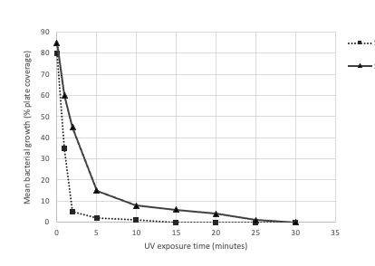

E. coli

S. aureus

(c) Explain why the bacteria broth and inoculated Petri dishes were incubated at 37ºC.
(2 marks)

Description | Marks
Human body temperature is around 37ºC. | 1
Optimal bacterial growth and reproduction would be at 37ºC.  or  Both bacteria grow and reproduce best in the human body. | 1
TOTAL | 1

(d) Suggest two (2) reasons for inoculating 10 Petri dishes with the bacteria broth for each UV exposure time. (2 marks)

Description | Marks
Two points for one mark each. Examples include, but not restricted to
- Calculate the mean/average.  - Reduces effect of experimental error, increasing data validity.  - Reduces the effect of outliers on data.  - Increases the chance of representative sampling/reduces chance effects.  - More reliability in drawing conclusions. | 1 - 2
TOTAL | 2

(d) Use your graph to estimate the UV exposure time required to completely inhibit growth of;

(i) Escherichia coli (1 mark)

Description | Marks
15 minutes | 1
TOTAL | 1

(ii) Staphylococcus aureus (1 mark)

Description | Marks
30 minutes | 1
TOTAL | 1

(e) Does this investigation have an appropriate control? Explain your response. (3 marks)

Description | Marks
Either 'Yes' or 'No'. | 1
For 'Yes'  - Zero exposure time plate  - controlled for growth under normal conditions. | 1 - 2
For 'No'  - Petri dishes containing no bacteria should be included  - as a comparison for growth against UV treated plates. | 1 - 2
TOTAL | 3

(f) State two (2) ways in which the students could improve the reliability of the investigation. (2 marks)

Description | Marks
Two points for one mark each. Examples include, but not restricted to
- Tighter/closer time intervals for UV exposure.  - Longer incubation time for inoculated Petri dishes.  - Petri dishes treated for inhibition of other bacterial growth.  - Apply UV at different strengths (as kJ m⁻1).  - More petri dishes inoculated for each time trial.  - Different method of quantifying bacterial growth. | 1 - 2
TOTAL | 2

Question 33 (20 marks)

(a) Compare the process of mitosis and meiosis by completing the table below. (6 marks)

Description | Marks
One mark per correct comparison (refer to table below). | 1 - 6
TOTAL | 6

Mitosis | Meiosis
One chromosomal division | Two chromosomal divisions
Chromosomes sorted evening into daughter cells. | Independent assortment
No bivalent pairing | Homologous pairs form bivalents
No exchange of genetic material (between homologues) | Crossing over occurs (meiosis I)
Two (2) daughter cells produced | Four (4) daughter cells produced
Daughter cells are diploid (2n) | Daughter cells are haploid (n)
Division of somatic (body) cells | Division of sex cells/gametes
Daughter cells are genetically identical | Daughter cells are genetically unique

Bacteria do not reproduce sexually and yet they are the most diverse group of organisms on Earth.

(b) Name the process by which bacteria reproduce. (1 mark)

Description | Marks
Binary fission (do not accept mitosis). | 1
TOTAL | 1

(c) Explain two (2) ways the genetic diversity of a bacterial species can be increased.
(4 marks)

Description | Marks
Mutation  DNA mutation introduces new alleles into gene pool. | 1 - 2
Conjugation  Process by which adjacent bacterial cells copy and share plasmid DNA. | 1 - 2
TOTAL | 4

Agrobacterium tumefaciens is a species of soil-borne bacteria that can infect plant cells and cause crown gall disease. A. tumefaciens is widely used in recombinant DNA technology as a vector for gene transfer.

(d) Construct a labelled flow diagram outlining the stages involved in the development of a transgenic plant using Agrobacterium tumefaciens. (6 marks)

Description | Marks
Identifies correct stages in correct order with arrows (refer to example diagram below).  *NB: accept correct flow diagrams without illustrations. | 1 - 6
TOTAL | 6

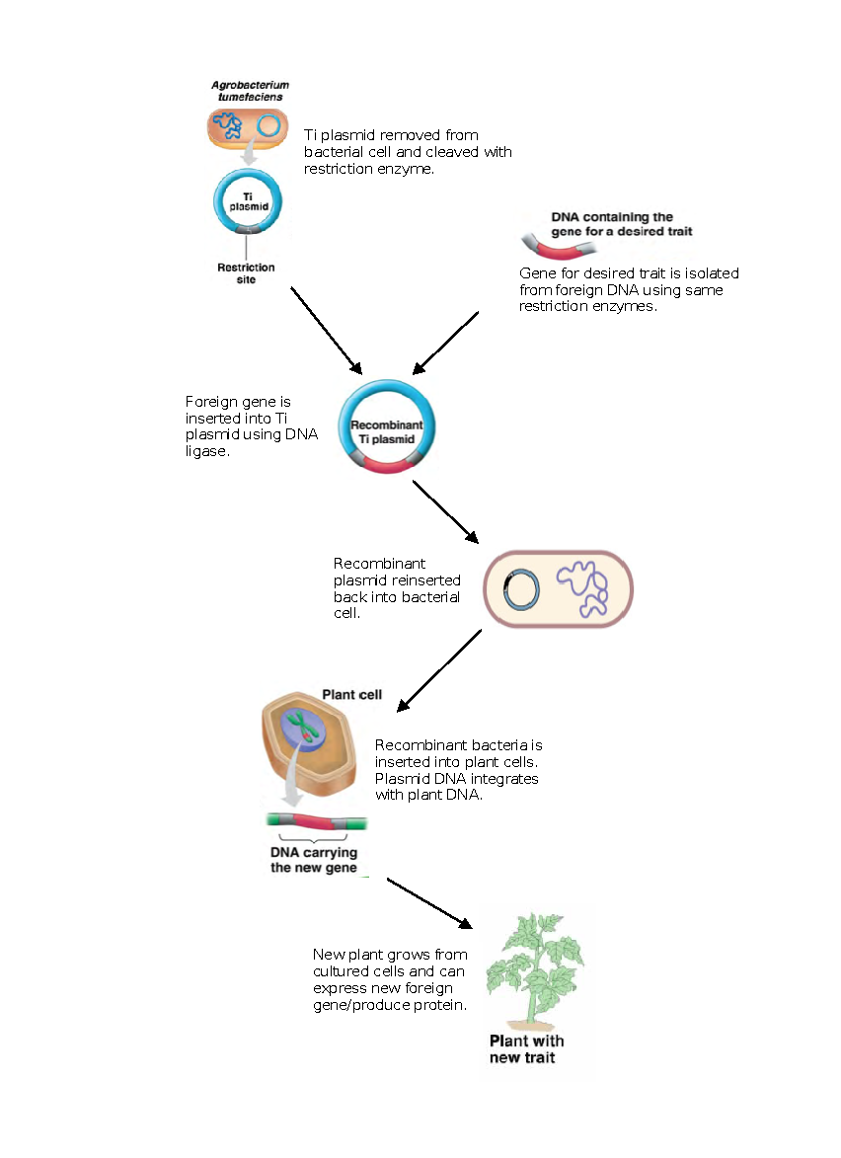

(e) Describe how scientists identify which bacterial cells contain recombined DNA. (3 marks)

Description | Marks
Antibiotic resistance gene also inserted into plasmid with foreign gene. | 1
'Recombinant' bacterial cells are grown in medium containing antibiotic. | 1
Cells that grow on medium contain recombined plasmid. | 1
TOTAL | 3

Question 34 (20 marks)

There are six subspecies of carpet python (Morelia spilota) in Australia. The table below contains information relating to two subspecies of the carpet python.

 | 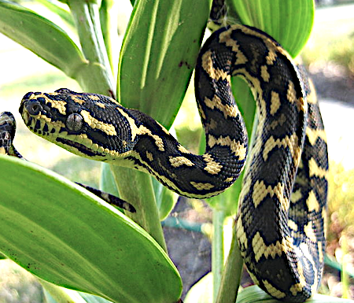  Jungle carpet python | 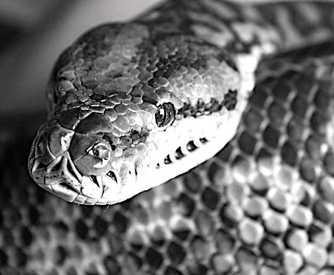  Murray Darling carpet python
Colouration | Black with bright yellow diamond banding. | Black and grey mottled skin with cream underside.
Habitat | Tropical rainforest | Inland open eucalypt forest and rocky outcrops.

(a) Explain how natural selection allowed for the evolution of these subspecies. (5 marks)

Description | Marks
Genetic variation exists in gene pool. | 1
Populations inhabiting different habitats have different selective pressures from the environment. | 1
Individuals with phenotypes favoured in each habitat/population survive and reproduce more frequently. | 1
Traits are passed onto successive generations. | 1
Genotypic frequency changes over time leading to evolution of subspecies. | 1
TOTAL | 5

A scientist used mitochondrial DNA (mtDNA) to determine subspecies divergence times.

(b) Suggest three (3) reasons why mtDNA was used in this investigation. (3 marks)

Description | Marks
Three points for one mark each. Examples include
- Mutation rate high (greater than nuclear DNA).  - mtDNA inherited from maternal line only.  - mtDNA abundant in cells.  - No genetic recombination as only inherited from mother.  - Useful for comparing recent divergence (= or >20 million years). | 1 - 3
TOTAL | 3

(c) Describe how each of the following provide evidence for evolution.

(i) Homologous structures (3 marks)

Description | Marks
Similar structures/underlying anatomy with a different function. | 1
Reveals shared evolutionary origin - ancestral organisms evolved into distinct forms due to differing selection pressures (adaptive radiation). | 1
More similar the structure between groups/species the closer the relatedness/more recent divergence. | 1
TOTAL | 3

(ii) Vestigial organs/structures (3 marks)

Description | Marks
Reduced and/or functionless remnants of organs or structures once present in ancestral species. | 1
Changes in selective pressures reduce use/need of structure over time. | 1
Demonstrates divergence from past behaviour or activity in ancestral species. | 1
TOTAL | 3

(iii) Biogeography (3 marks)

Description | Marks
Distribution of organisms over geographical areas. | 1
Closely related species usually found in close geographical proximity.  or  Closely related species may be found in previously connected land masses. | 1
Fossils found in these geographical areas resembling living species suggests common ancestry. | 1
TOTAL | 3

(d) Use a specific example to explain how sexual selection may increase the frequency of a trait that does not improve an organism's chance of survival and reproductive success. (3 marks)

Description | Marks
Appropriate example.  E.g. peacock tail, bright plumage in male birds, courtship rituals, building impressive structures, large horns. | 1
Sexually selected trait/phenotype may make organism more susceptible to predation (no camouflage or cumbersome structures). | 1
Only those male individuals with most impressive trait will be selected to mate while most may never mate and pass on genes. | 1
TOTAL | 3

Question 35 (20 marks)

A large wildlife sanctuary was monitoring the breeding behaviour of a population of the carnivorous agile antechinus (Antechinus agilis). Like most species from the family Dasyuridae, the agile antechinus is highly promiscuous. Each female is able to produce a litter of up to 12 offspring by multiple fathers.

Researchers profiled the DNA of four juvenile agile antechinus from one litter, against the DNA from the three possible fathers. The purpose of this research was to select juveniles with different fathers for a breeding program at the Melbourne Zoo.

A selection of comparable short tandem repeats (STRs) was isolated from the genome of each antechinus.

(a) Define 'short tandem repeat'. (2 marks)

Description | Marks
Segment of non-coding DNA | 1
with the same sequence of nucleotides repeated. | 1
TOTAL | 2

(b) Explain why STRs are used in genetic profiling. (3 marks)

Description | Marks
Three points for one mark each. Examples include
- Unique to each individual.  - Inherited from both parents.  - Many different STRs in genome.  - Useful for proving paternity/parentage. | 1 - 3
TOTAL | 3

Gel electrophoresis was used to visualise and compare the antechinus DNA.

(c) Outline the basic principles behind the use of gel electrophoresis for DNA profiling.
(5 marks)

Description | Marks
Five points for one mark each.
- DNA has an overall negative charge.  - DNA fragments are separated based on size/number of bases/molecular weight.  - Process uses an electric current passed from a positive to negative probe.  - DNA fragments placed in wells in the gel at negative probe end.  - Small fragments migrate further through the gel than large fragments.  - Migration of DNA fragments from each well creates a DNA 'fingerprint' or unique band pattern.  - Band patterns can be compared with other samples for similarities. | 1 - 5
TOTAL | 5

Possible Fathers Juveniles
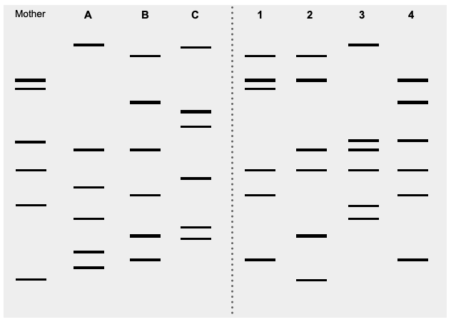

(d) Using the information above, identify the father of each juvenile antechinus. (4 marks)

Description | Marks
Juvenile 1 - B | 1
Juvenile 2 - B | 1
Juvenile 3 - A | 1
Juvenile 4 - B | 1
TOTAL | 4

(e) Based on the paternity results, which of the offspring would be most suitable for the breeding program? Explain your choice. (2 marks)

Description | Marks
- Juvenile 3  - Juvenile 3 has a different father to the other juvenile antechinus.  OR  - Juvenile 3 and one other from 1, 2 or 4.  - Juvenile 3 has different father and only one can be chosen from the remaining as they share the same father. | 1 - 2
TOTAL | 2

Captive bred animals are eventually released into their natural habitat.

(f) Discuss one (1) factor that should be considered prior to their release. (2 marks)

Description | Marks
One mark for appropriate factor and one mark for explanation. Examples include, but are not restricted to
- Habitat size - is the natural habitat a suitable size to allow a sufficient population to grow or allow for territorial behaviours.  - Habitat fragmentation - is the natural habitat connected to adjacent areas via wildlife corridors to allow gene flow between populations.  - Existing natural population - is the population of existing animals large enough or genetically diverse enough to support conservation efforts. | 1 - 2
TOTAL | 2

(g) Identify two (2) other applications of gel electrophoresis in biotechnology. (2 marks)

Description | Marks
Two points for one mark each. Examples include, but not restricted to
- Forensic testing (crime analysis).  - Genetic disease diagnosis.  - Phylogenetics - species comparison.  - Protein separation.  - Identification of unknown samples (e.g. illegal wildlife trade).  - Testing restriction enzymes.  - Conservation genetics. | 1 - 2
TOTAL | 2

End of Section Two

Section Three: Extended answer 20% (40 marks)

Part A

Question 36 (20 marks)

(a) Describe the process of DNA replication and its importance to the survival of all living organisms. (10 marks)

Description | Marks
Description of DNA replication process should include at least eight points from below. Each point is worth one mark.
- DNA replication is semi-conservative - each new strand has half new and half original DNA.  - Replication occurs at multiple sites along the chromosomes to increase speed.  - Helicase unzips DNA to create a replication fork.  - DNA replication is in a 3' to 5' direction.  - Each strand of the double helix is used as a template for the new strand.  - The leading strand is synthesised in 5' to 3' direction towards the replication fork.  - DNA polymerase adds new nucleotides on the leading strand.  - Addition of nucleotides is governed by the base-pairing rule A - T and C - G.  - The lagging strand is synthesised by the addition of Okazaki fragments away from the replication fork - 5' to 3' direction.  - RNA primase/RNA primer and DNA polymerase are responsible for the addition of Okazaki fragments.  - Okazaki fragments are joined together by DNA ligase. | 1 - 8
Importance to survival should include at least two points. Each point is worth one mark. Examples include, but are not restricted to
- All living organisms use DNA as their genetic material.  - DNA replication is crucial to production of new cells.  - Growth and repair cannot occur without DNA replication.  - Production of gametes for sexual reproduction requires replication of DNA. | 1 - 2
TOTAL | 10

(b) Discuss the positive and negative aspects of producing genetically modified agricultural crops.
(10 marks)

Description | Marks
Students must discuss at least five different benefits/positives relating to the production of genetically modified crops. Each point discussed is worth one mark. Examples include, but are not restricted to
- Improved nutritional value of food - higher vitamin content, more protein.  - Crops can be grown in drought affected areas with a better yield - drought resistant genes.  - Production of crops without known allergens - used by more people.  - Crops can be modified to be herbicide resistant - weeds can be killed without harm to crop.  - Crops can be produced to be resistant to insect damage - gene inserted and expressed to inhibit insect consumption.  - Increased shelf life of some crops - less spoilage and food waste.  - More economic to produce crops that produce a greater yield with less external input - less water, nutrients, land and pesticides required.  - Crops can be modified to produce different ratios of oil for biodegradable, plant-based plastic production - reduces petrochemical use and plastic waste. | 1 - 5
Students must discuss at least five different risks/negatives relating to the production of genetically modified crops. Each point discussed is worth one mark. Examples include, but are not restricted to
- New traits introduced into crop plant genome could have adverse health effects - allergic responses.  - Removing traits from plants could have unknown future effects - on nutrition, plant function.  - Limit biodiversity of local environment by competing with native species.  - Cross pollination may produce superweeds that cause ecological problems.  - Genetically modified crops may be patented by large companies that monopolise the industry.  - Regulation of GM product use is variable from place to place making it difficult to govern/manage.  - GM crops may inadvertently pollinate 'organic' crops, causing loss of certification and income. | 1 - 5
TOTAL | 10

Question 37 (20 marks)

(a) Describe the process of translation in a cell.
(10 marks)

Description | Marks
Description of translation should include 10 points from below. Each point is worth one mark.
- Translation involves the synthesis of a new polypeptide/protein.  - Translation occurs at the ribosomes.  - mRNA leaves the nucleus and binds with a ribosome/ribosomal subunit (at initiation site).  - mRNA is read by the ribosome in a 5' to 3' direction from the START codon.  - Each codon on mRNA codes for an amino acid.  - tRNA (transfer RNA) molecules contain an anticodon complementary to each mRNA codon.  - tRNA deliver specific amino acids to the ribosome.  - As the ribosome reads the mRNA the complementary tRNA delivers the correct amino acid.  - tRNA attaches to the complementary mRNA codon.  - Ribosome reads the next mRNA codon and another tRNA (carrying the required amino acid) is attached.  - A peptide bond is formed between the adjacent amino acids.  - The first tRNA is released from the mRNA/ribosome, leaving the amino acid behind.  - The ribosome moves along the mRNA to the next codon and another tRNA is attached (carrying corresponding amino acid).  - A new peptide bond is formed between the amino acid and the new polypeptide chain (1st and 2nd amino acids).  - The second tRNA can now be released from the ribosome.  - This process is repeated as the ribosome moves along the mRNA molecule until a STOP codon is reached.  - The completed polypeptide chain is released from the ribosome and delivered to the Golgi apparatus for processing. | 1 - 10
TOTAL | 10

(b) Discuss how biotechnology can help to reduce the risk of extinction for endangered species.
(10 marks)

Description | Marks
Discussion should include 10 points from the following worth one mark each. Examples of how biotechnology can help reduce risk of extinction include, but are not restricted to
- DNA Profiling  - DNA profiling of individuals in species populations to monitor gene pool.  - Identification of populations most at risk.  - Identification of hybrids in populations.  - Assess gene pool diversity for captive breeding programs.  - Selection of suitable individuals from the population to breed.  - Identification of genetically different individuals from other populations for translocation. | 1 - 4
- Genetic modification/recombinant DNA technology  - Introduction of a new gene from an alternate, diverse population.  - Introduction of a gene from a different species to express a trait that will increase chance of survival.  - Directly edit a species genome to produce genetically superior individuals.  - Genetically modified or transgenic individuals are better adapted to respond to future threats (disease, climate change). | 1 - 3
- Artificial propagation  - Plant tissue culture used to propagate endangered species.  - Propagated species can be translocated into the natural environment to increase numbers and diversity.  - In vitro fertilisation using donor eggs and/or sperm from endangered species. | 1 - 3
TOTAL | 10

Part B

Choose either Question 38 or Question 39.

Question 38 (20 marks)

(a) Discuss how gene flow and mutation influence genetic variation in populations. (10 marks)

Description | Marks
Discussion of the influence of gene flow on genetic variation should include at least six points from below. Each point is worth one mark.
- Gene flow refers to the movement/transfer of genes or alleles between interbreeding populations of the same species.  - Gene flow is an important mechanism for transferring genetic diversity amongst populations.  - Gene flow within a population can increase the genetic variation of the population.  - Migration between populations can change the allelic frequencies of the populations.  - The introduction of new alleles (via gene flow) increases variability within the population and provides the possibility for new trait combinations.  - Migration changes the distribution of genes and genetic diversity within populations.  - High rates of gene flow can reduce the genetic differentiation between gene pools and increase homogeneity of alleles.  - High gene flow reduces possibility of speciation by constraining the development of genetic differences between populations.  - Reduced gene flow between populations becoming genetically distinct.  - Reduced gene flow promotes divergence between populations and a greater degree of genetic variation between populations. | 1 - 6
Discussion of the influence of mutation on genetic variation should include at least four points from below. Each point is worth one mark.
- Mutations are random changes in the genetic composition of an organism due to changes in the base sequence of DNA.  - Mutations that occur in germ line cells (gamete production) introduce new alleles into a population, increasing variation.  - Mutations are the raw material of genetic variation and drive evolution.  - Mutations can alter the product or a gene (function of the protein/enzyme) which introduces a different trait into the population/gene pool.  - Mutations that influence variation can be advantageous, deleterious or indifferent to the 'fitness' of an organism and/or population.  - Mutations can introduce phenotypes into a population that are favoured through natural selection, causing a change in the phenotypic frequency. | 1 - 4
TOTAL | 10

(b) Discuss the concept of genetic drift and associated effects on genetic diversity. (10 marks)

Description | Marks
Genetic drift overview should include at least four points. Each point is worth one mark. Examples include
- Genetic drift is the change in the composition of a gene pool as a result of a random or chance event/sampling error.  - Genetic drift has a greater impact on small populations because chance effects have a bigger impact on the gene pool.  - Genetic drift may result in the loss of alleles from a gene pool, decreasing diversity of the population.  - Larger populations are less affected by random/chance events and retain stable allele frequencies with low genetic drift.  - Genetic drift can result in the fixation of an allele/s (beneficial and deleterious) in the gene pool. | 1 - 4
Founder effect discussion should include three points worth one mark each. Examples include
- A small group breaks away from the main population to colonise a new area.  - The new founding population does not contain the same level of genetic diversity as the main population.  - Alleles may be completely lost from the gene pool of the founding population.  - The small population with reduced diversity will be subject to a higher level of genetic drift.  - As the founding population increases in number, their gene pool no longer represents the original population. | 1 - 3
Bottleneck discussion should include three points worth one mark each. Examples include
- Population bottlenecks occur when natural or human events cause a dramatic reduction in the size of a species population.  - The surviving population contains less genetic diversity/variation and therefore a reduced gene pool.  - Alleles can be completely lost from the population during a bottleneck event.  - As the surviving population is re-established, it is no longer representative of the original population or gene pool. | 1 - 3
TOTAL | 10

Question 39 (20 marks)

(a) Describe the process of selective breeding in agricultural livestock. Identify any problems that may arise as a result of this process. (10 marks)

Description | Marks
Description of selective breeding process should include at least six points. Each point is worth one mark. Examples include
- A process by which humans breed animals (and plants) for particular genetic traits/characteristics.  - The desired traits are chosen for usefulness (e.g., increased milk production, leaner meat) or appearance (e.g., hair colour).  - Parents with the desired trait/s are selected from a mixed population.  - The parents with the desired trait/s are bred together.  - The best offspring showing the desired trait are selected to breed.  - The process of selection and breeding is continued over many generations until all offspring born possess desired trait.  - Final population will comprise individuals that all possess the desired trait. | 1 - 6
Identification of problems should include at least four points worth one mark each. Examples include, but are not restricted to
- Selective breeding may lead to inbreeding - related animals may be bred together.  - Inbred individuals are more prone to disease or inherited genetic defects.  - Can lead to a reduction in genetic diversity of the bred population.  - May lead to the production of animals with undesirable characteristics that are harmful to their health.  - May lead to the complete loss of alleles from the population. | 1 - 4
TOTAL | 10

(b) Discuss the concept of adaptive radiation as a mechanism for speciation. Use a specific example to support your response.
(10 marks)

Description | Marks
General discussion of adaptive radiation should include at least six points worth one mark each. Examples include, but are not restricted to
- Rapid evolutionary diversification of descendants of a single ancestor/ancestral group/lineage.  - Adaptive radiation may occur in response to environmental change (e.g., new island formation, ice age, climate change, desertification) and resource availability.  - Geographical isolation from the ancestral species can trigger adaptive radiation due to different selective pressures.  - Adaptive radiation is a response to an opportunity presented to organisms that possess the appropriate adaptation.  - New niches are occupied/filled over time due to variation in selection pressures.  - Mass extinction events are often followed by rapid diversification of remaining species - adaptive radiation - as new niches are made available. | 1 - 6
Specific example of adaptive radiation is worth four marks. Example must include
- Organism group/lineage (e.g., Galapagos finches, Australian marsupials, hummingbirds, lemurs, chameleons).  - Trigger for adaptive radiation (e.g., different food, geographical isolation, mass extinction).  - Adaptive change in phenotype/characteristic (e.g., beak shape, body size, skin colour).  - Result of adaptive radiation on species evolution/speciation (e.g., finches fill all available food resource niches, marsupials diversified to fill/adapt to every ecosystem in Australia). | 1 - 4
TOTAL | 10

End of questions

